Bramhall Photographic Society
CONTINUING WITH PICTURES TO EXE
This time we will look at four more things you can do in Pictures to Exe

Pan, Zoom, Rotate and also placing a new image over an existing slide, and have it appear from one position, and possible from 0% opacity rising to 100% opacity by the time it reaches the chosen position. This chosen position can be anywhere, and any size, over the 1st slide. It can, if you wish, completely cover the 1st slide as its final position, before the transition which brings in the following slide.

1. Pan
The image which you are going to pan will need to be wider than the rest of your images.
Click on Objects and Animation at the bottom of the screen, and you will see that your image is larger than the black background behind it. Right click on the image and you will see a bounding box with 'grab handles' size your image with one of these corners and position it so there is no black showing top or bottom, and your image is lined up on the left with the black background. The right hand side will be greyed out because it runs outside of the black background (the slide size)
Once you have it lined up correctly, right click on the key frame on the timeline at the bottom of the screen and choose duplicate and drag it to the end, where there is a blue line. Now you can move your slide along so that the right hand side lines up with the black background, and the left hand side is now greyed out.
Unless you have already given this slide a longer time to play than the others, it may pan much too quickly, so close this screen and alter the time for the slide to something more suitable. Keep playing and altering the seconds of playtime until you are happy with the result.

A simple pan would be the two key frames
One at the beginning and one at the end. The screen shots below show the two positions of the image, to get this simple pan

. 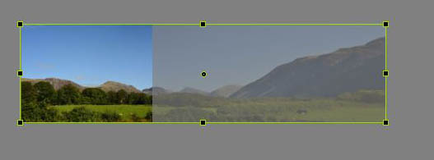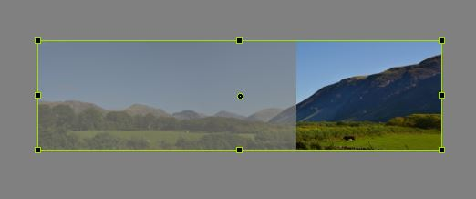

2. Zoom
The image you wish to zoom can be larger than the others to allow for zooming in/out.
Zooming out is slightly more preferable to zooming in (in some cases) as it keeps the viewers interest whilst the full image appears.
Select the slide to zoom and click on Objects and Animation make sure your image is 'active' and resize so that the point of interest is positioned where you prefer. This will be your first Key Frame
Now duplicate this Key Frame by Right click on it and choosing duplicate and then drag this to the end of this timeline. Now resize your image again, bringing it back to its original size by filling the black background.
Unless you have already given this slide a longer time to play than the others, it may zoom much too quickly, so close this screen and alter the time for the slide to something more suitable. Keep playing and altering the seconds of playtime until you are happy with the result.
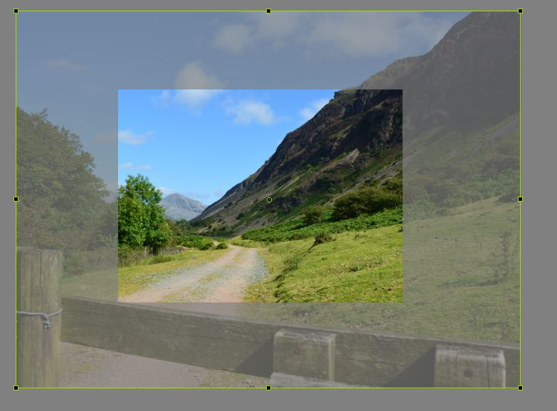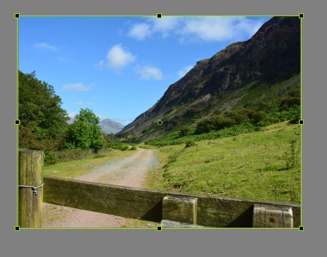

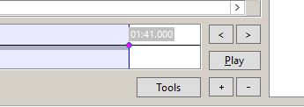
If you right click the small + sign, on the tool bar at the bottom of the screen, this will also add a key frame, in this case it has placed it close to the 1st one, but this can be dragged to whatever position you wish. We would want this at the end or close to the end. If it is placed a little way away from the end that means the full image (after the end of the zoom) will stay onscreen a little while before moving into the transition for the next slide too quickly.

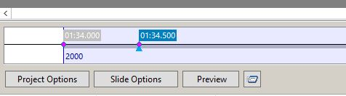

3. Rotate
Choose the slide you wish to work with, and on the bar across the base of the screen choose Objects and Animation.
Make a new key frame as before or by using the + sign and then drag it to the end position.
In the boxes on the right hand side you will see Rotate, under pan and zoom
(360% would turn full circle)
The length of you slide playing time obviously determines the speed at which this turns. A longer slide will play more slowly.

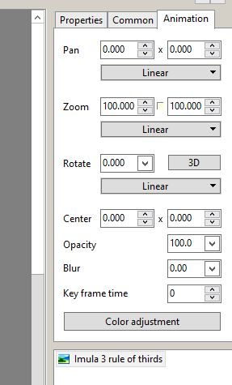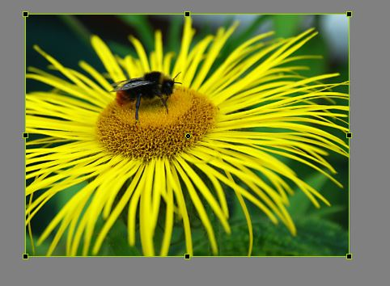

These two images show how the image and setting would look for the first key frame. Nothing here is altered in the Animation box.
The next two images show how the settings and the image would look for the second key frame, if you alter the ‘rotate’ to 90 for the 2nd key frame.
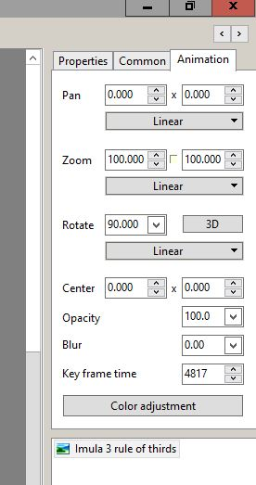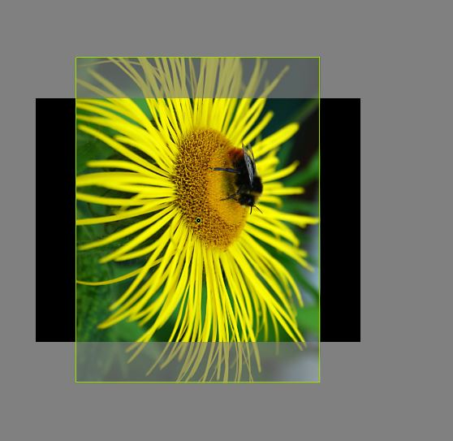

4.Placing an animated image on top of a background image.
Choose the slide you wish to work with, and on the 'bar across the base of the screen' choose Objects and Animation, my chosen image was a flower border, because I wanted to have a plant which was in this border to come forward as a separate and more detailed image.
When this screen opens, along the top you will see an option to "Add Image" This is the 7th icon along the top left looking like a photograph.
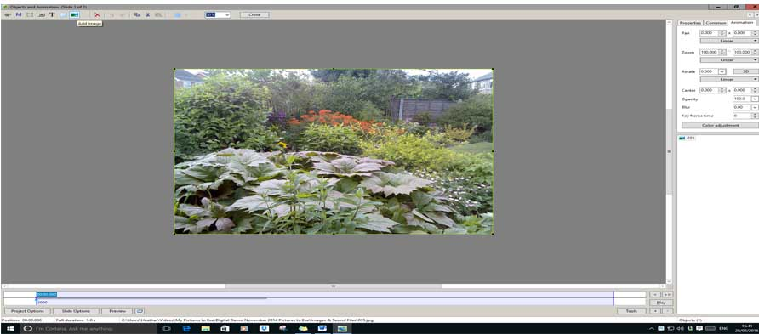

Before you click on this, make sure you have clicked inside your main image and can see a bounding box around it, when you then click on Add Image you will see the actual folder of pictures are working with where you can choose your image. Click on your chosen image and click 'open'
You will now have this image on top of the background image - this is when you place it exactly where you want it to appear from, what size you want it to start at, and also what % opacity you would like it to start off from.
Right click on the1st key frame, choose duplicate key frame, then drag this nearly to the end bar, which is where the main slide finishes playing. Now choose 100% opacity and enlarge the image to how you wish to see it for the final seconds of the main slide.
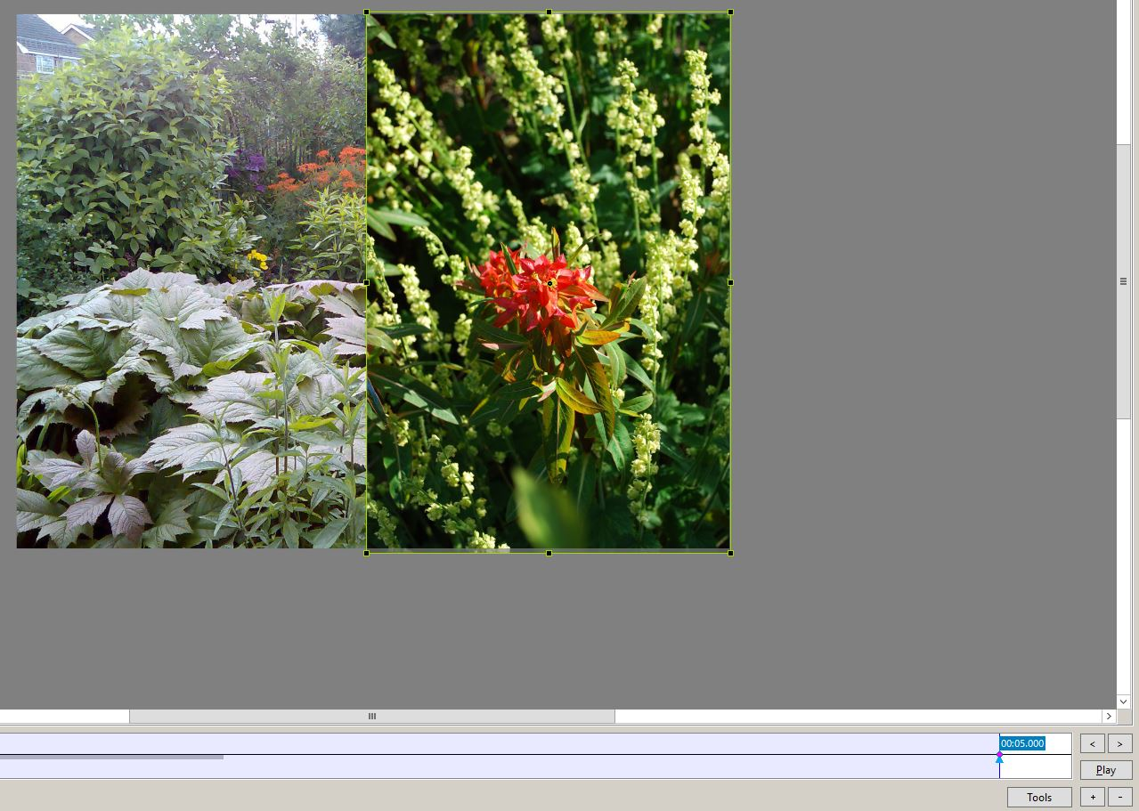
This is a screen shot of the 2nd key frame and the new position of the 2nd image.
Click the play tab and see how it looks - you may wish to have another position for the image before it reaches its last position - in which case you add another key frame and resize/move the image again. If it all seems to be playing too fast, close this screen BUT NOT THE PROGRAM! and on the slide itself you can change the default seconds to something more suitable10/12/15secs. Play this section again, and if you want to make alterations in time you can do so now, then if you want to change the movement in any way of the top slide just go back to Objects and Animations, and move the image to where you like. This is very much "trial and error" but very easy to go back and forwards until you have something satisfactory.
Why stop there, you can add more images if you like. My own intention was to pick out several flowers in my flower border and have them appear from their place in the border to be positioned as flower pictures in their own right overlaid on the border image. One day I will.

I do hope these notes are helpful to beginners in Pictures to Exe.
If I have not explained myself clearly enough, please feel free to contact me at
heather.carslake@sky.com
More information is also easily available on the Pictures to Exe Website and also on YouTube

