Bramhall Photographic Society
PHOTOSHOP ELEMENTS
AN INTRODUCTION TO LAYERS
(This technique will work in any version of Elements although the screenshots may vary slightly)
The Layers panel is a very important and powerful tool in Photoshop. It allows various parts of an image to be isolated and manipulated without affecting other parts of the image. The following technique will demonstrate how Layers work and will allow you to experiment with some of the basic interaction of Layers.
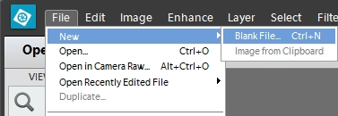
Start by creating a new blank file.
From the main menu choose
File / New / Blank File
or hit Ctrl+N on the keyboard.
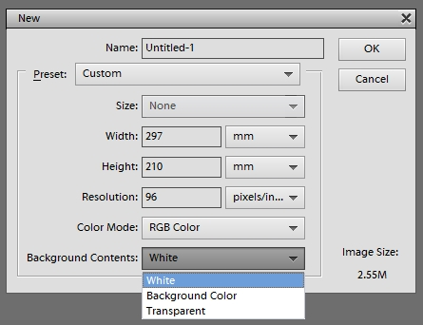

The New File dialogue box is displayed.
The size and shape of the document is relatively unimportant at this stage but make sure that the ‘Background Contents’ is set to White.
Click on ‘OK’ and your blank document is displayed.

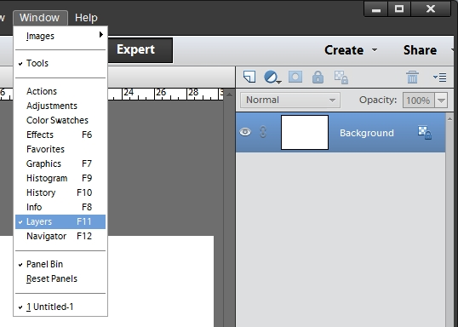
The Layers Panel should be displayed on the right of the screen. If not, choose ‘Window’ from the main menu and click on ‘Layers’ or hit F11 on the keyboard.
In the Layers Panel, the small padlock icon to the right of the word ‘Background’ indicates that this is a locked layer and cannot be edited.
That’s fine because we want to leave it as a plain white background.

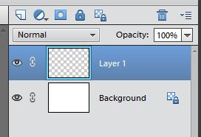
Now create a new blank layer.
Do this by clicking on the ‘Create new layer’ icon at the top of the layers panel (at the bottom on some versions). The icon looks like a sheet of paper with a corner turned over.
Layer 1 now appears above the background layer in the Layers Panel and is highlighted in blue to show that it is currently the active layer. The chequerboard pattern indicates complete transparency
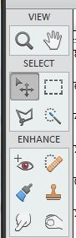
The ‘Eye’ icon to the left in the Layers Panel is the visibility control for each layer. Try clicking the eye for the Background layer off and on to see what happens.

Next, we will create a simple shape, a blue square, on this layer. Choose the Marquee Tool from the Toolbar. This appears as a dotted square.
Make sure that Layer 1 is active and draw a rectangle on the blank screen by left-clicking and dragging the mouse. You can draw any shape of rectangle but holding down the Shift key at the same time constrains the shape to a perfect square. The dotted outline is sometimes referred to as ‘Marching Ants’ for obvious reasons.
Click on the Foreground Colour Tool in the Toolbar and choose a suitable shade of blue from the colour picker. Click OK.

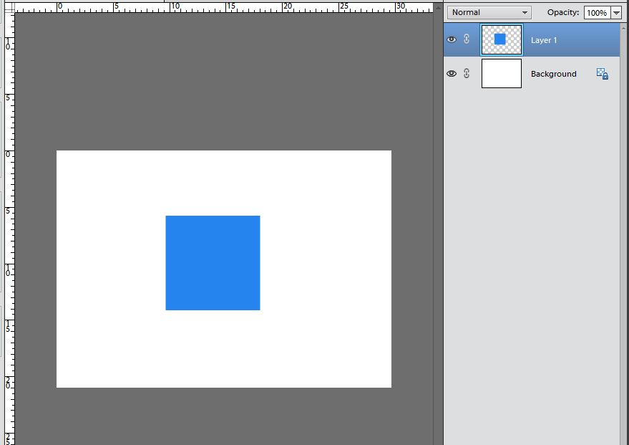
Choose the Paint Bucket tool from the Toolbar and click inside the square you have just drawn – it will fill with your blue colour. You can now get rid of the ‘Marching Ants’ by going to the main menu and choosing Select / Deselect or hit Ctrl+D on the keyboard. Your screen should now look like this:

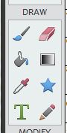
The thumbnail view in the Layers Panel should show a blue square surrounded by the chequerboard pattern (transparency) but the main image looks like a blue square on a white background.
That is because you are looking through the transparent part of Layer 1 to the Background layer below.
Now follow all the instructions from the top of the previous page to create a Red Circle on a new layer. The main difference is that when you pick up the Marquee Tool you should choose the Elliptical option rather than Rectangular. Again, holding the Shift key whilst dragging will constrain the shape to a perfect circle.
All being well you should now be seeing a screen like this:
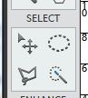
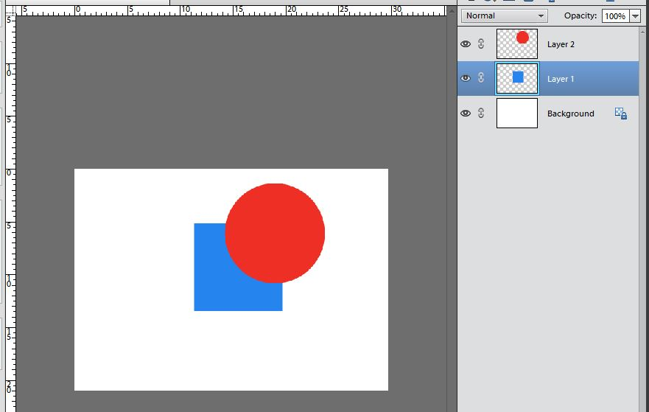
Now choose the Move Tool from the toolbar – it looks like a four-way arrow.
Using the mouse you can now move the Red Circle independently of the Blue Square.
Likewise you can move the Blue Square by making its layer active.
With Layer 1 active hold down the Ctrl key and click on Layer 2 so that they are both active. The Move Tool now moves both layers in unison.

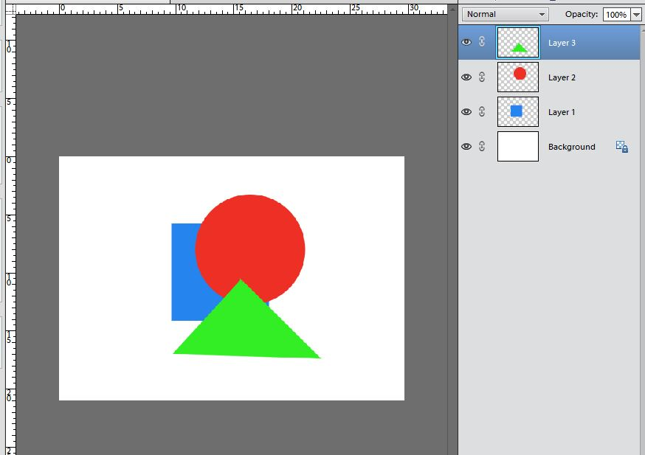
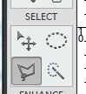
Now, make the top layer active by clicking on its name in the Layers Panel and using the same basic instructions from the top of the previous page, create a new layer with a Green Triangle. To create a triangle shape, use the Polygonal Lasso Tool. Click where you want the apex to be, release and drag the line diagonally downwards and click again to end the line, release and drag horizontally to form the base and click again, release and drag diagonally upwards back to the starting point and click to complete the process. Elements will join the start and finish points to form an enclosed triangle which you can then fill with Green colour as before.
You can change the order of layers in the Layers Panel by simply dragging a layer to a new position. e.g. click and hold on layer 3 and drag down to a position between layer 2 and layer 1. The Green Triangle now appears to be behind the Red Circle but in front of the Blue Square. By this method layers can be arranged in any sequence required.
Notice that the layer name does not change.

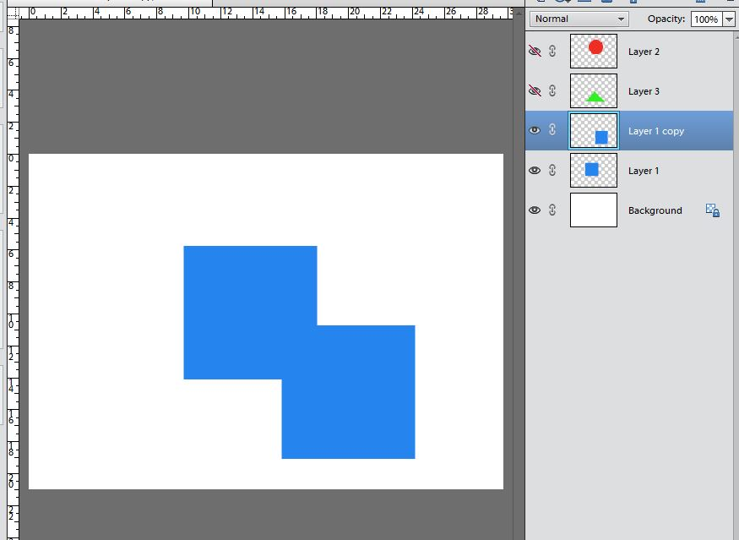
Layers can also be duplicated. For example, click on Layer 1 to make it active and turn off the visibility of Layers 2 and 3 by clicking on their respective ‘Eye’ icons. You should now have just a Blue Square in the main image. From the main menu choose Layer / Duplicate Layer or hit Ctrl+J on the keyboard. The main image is unchanged but in the Layers Panel you should see Layer 1 Copy has appeared above Layer 1. Using the Move Tool drag the Square a little way down and to the right to create a new shape as shown:
The new shape is of course two squares on separate layers but they can be combined together to form one new layer. With Layer 1 Copy already highlighted hold down the Ctrl key and click on Layer 1 so that both layers are active. From the main menu bar choose Layer / Merge Layers or hit Ctrl+E on the keyboard. You will see in the Layers Panel that these two layers now appear as one.
However you have now lost the ability to manipulate the two squares independently, so this control should be used with care,

Turn the visibility of all layers back on and click on the top layer to make it active.
We can now look at another very important control in the Layers Panel – the Opacity Tool
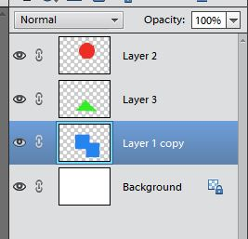
By default the Opacity is set to 100% but can be manually set to any lower value (0% being transparent) by either typing a value into the box or by clicking the small down arrow and using the slider control. The Opacity Tool only controls the currently active layer and has no effect on other layers. Try setting the opacity of the top layer to 50%. The main image shows the effect of the reduced opacity but the thumbnail in the Layers Panel is not affected and still shows the actual contents of the layer.
The other control at the top of the Layers Panel is the box marked ‘Normal’. The small down arrow reveals numerous ‘Blending Modes’. These control how the pixels in the active layer interact with those in the layers below.
The use of Blending Modes can have dramatic effects on photographic images but is beyond the scope of this basic tutorial.
Layer names can be amended by simply clicking on the name and typing something more descriptive of what has happened on that layer. For example Layer 1 Copy above could usefully be re-titled ‘Squares Merged’.
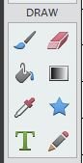
Working with Text
Text can be added to an image using the Text Tool in the toolbar – it looks like a large letter ‘T’.
Make the top layer active and click on the Text Tool. There are lots of options attached to this tool but for now just set the font to Arial Regular, the font size to 60pt and colour to Black and type in some text e.g. ‘Shapes’. Click on the green arrow or anywhere outside the image to commit the text.
Notice that in the Layers Panel the text automatically appears on a new layer which has been named according to the text you typed. Double-clicking on the thumbnail in the Layers Panel brings up all the text options again allowing you to changed font style, size, colour etc.

Your final image and Layers Panel should look something like this:
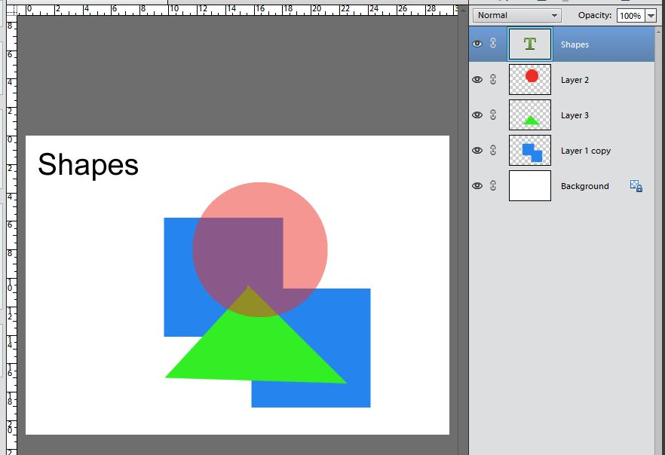
This tutorial has only scratched the surface of what is achievable using layers in Photoshop Elements but has hopefully demonstrated the basic principles behind the operation of layers.
The screenshots used are from Elements version 12 but the principles apply to all versions although some controls and tools may appear in slightly different locations in other versions.
References to the ‘Ctrl’ key should read ‘Command’ if using a Mac computer.

SUMMARY:
In this tutorial we have learned some the basics of how to:
- Create a new blank file
- Display the Layers Panel
- Create new blank layers
- Control layer visibility
- Use the Rectangular and Elliptical Marquee Tool
- Use the Colour Picker
- Use the Paint Bucket Tool
- Use the Move Tool
- Combine layers so that they can be moved in unison
- Use the Polygonal Lasso Tool
- Change the order of layers
- Duplicate layers
- Merge layers permanently
- Control layer opacity
- Rename layers
- Add text to an image

You are recommended to experiment with all these tools and techniques until you are familiar with how layers work in Photoshop and Elements.
I hope you found this tutorial useful. If you have any questions or comments please contact the author Graham Porter gasport@ntlworld.com
November 2015

