Bramhall Photographic Society
Introduction to Pictures to Exe
The Website for this Software is www.wnsoft.com/picturestoexe/
Below are two Screenshots, to give you an idea what you will see. There are lots of links from this page which explain about the program and will give both pricing details and differences between the two versions. The deluxe version is more comprehensive and, I feel, is worth the extra cost.

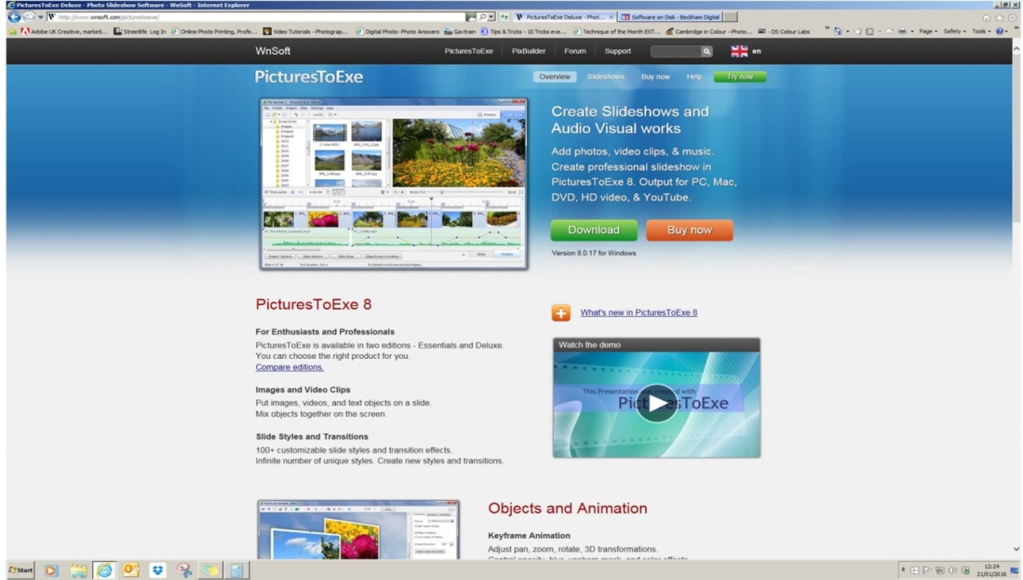
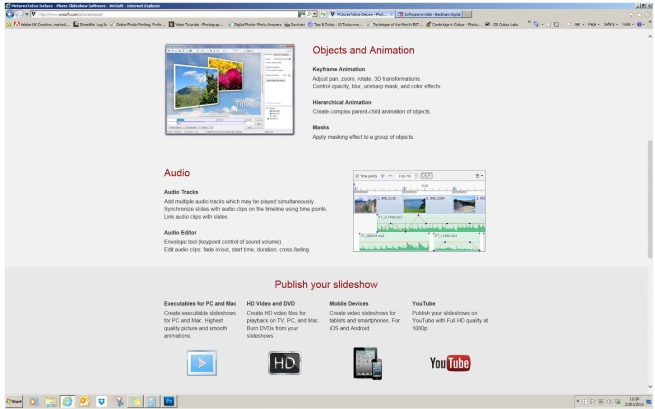
Last time I looked online V8 (the latest) was $154 (equal to around £109)
Purchasing more than one copy- they do give a discount to camera clubs and AV groups.
Anything over 6 copies would qualify for a 24% discount, making a considerable reduction.
2 copies = 6% discount
3 copies = 12% discount
4 copies = 15% discount
5 copies = 20% discount
6 or more copies = 24% discount
I worked out that 6 copies would reduce the cost to around £83 each
Unfortunately, up to date, this program does not run on Mac computers
Lots of tutorials can be found on both the website and on YouTube. Also on the Barry Beckham site, for which there is a link within wnsoft site.

A trial version is also available for download, to enable practice and decide if it is for you. The trial version has all the facilities of the full version except that it will only accept a very limited number of images and also has the Wnsoft logo on each frame. The trial program has no expiry time, so is well worth ‘giving it a go’

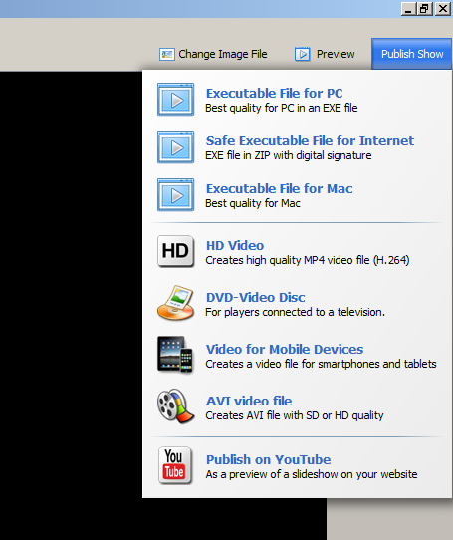
Although this screen shot should appear at the end of this tutorial – I have inserted it here to show what kind of files can be produced with this program.

The first one (Exe file for PC) is the one use we would use for Camera Club AV entries, and it plays on any computer. The computer does not require that Pictures to Exe is installed – it runs independantly.

3rd from the top (Exe File for Mac) is helpful. Some programs produce either a Mac suitable file or a Windows suitable file.
Though, as mentioned previously, this program itself wont work on a Mac, but will make a Mac suitable video on a Windows p.c.

3rd from the bottom option (Video for Mobile Devices) I find useful, to be able to put the same video onto my iPad.

Before actually starting to make your slideshow it is important to collect together all the images you want, plus some music options.

A sensible place to keep all these would be in a folder in the My Videos library. COPIES of the images you require should be placed in this folder, because they are going to need to be resized, and any alterations made, will therefore not be done on your original images.

Any MP3 music files you might want to use should also be copies, for the same reason – you may want to alter it in some way, and need to keep your originals safe.
To keep this Folder tidy, a good idea is to name it with your ‘Project’ name i.e. “2015 07 Barbados Holiday” then place 3 folders inside – 1) copied from original images 2) music files, and 3) resized images. The reason for keeping your copied from original images is that you may want to resize them some other time, to make the same slideshow for a widescreen p.c.

A quick way to resize the images is to use the crop tool set to 1400px x 1050 and 100 resolution.

Alternatively, in Elements or Photoshop, choose File – New – and fill in the boxes with the pixel sizes and resolution, and choose Black background.
Open your image and choose Select – All, then Edit – copy, then go to the black document and Edit – paste.
This places your image into the correctly sized document. It will likely be much too large, so go to Edit – Free transform and whilst holding down the Shift key (to constrain proportions) pull in a corner handle until the image fits in. The image may have black space at either the sides or above and below because of the aspect ratio.
This is not ideal for a slideshow, but if you have two portrait sized images, it could then fill the document.

Shortcuts for some of these actions are :-

Ctrl + A Selects
Ctrl + C Copies
Ctrl + V Pastes into another open document/image

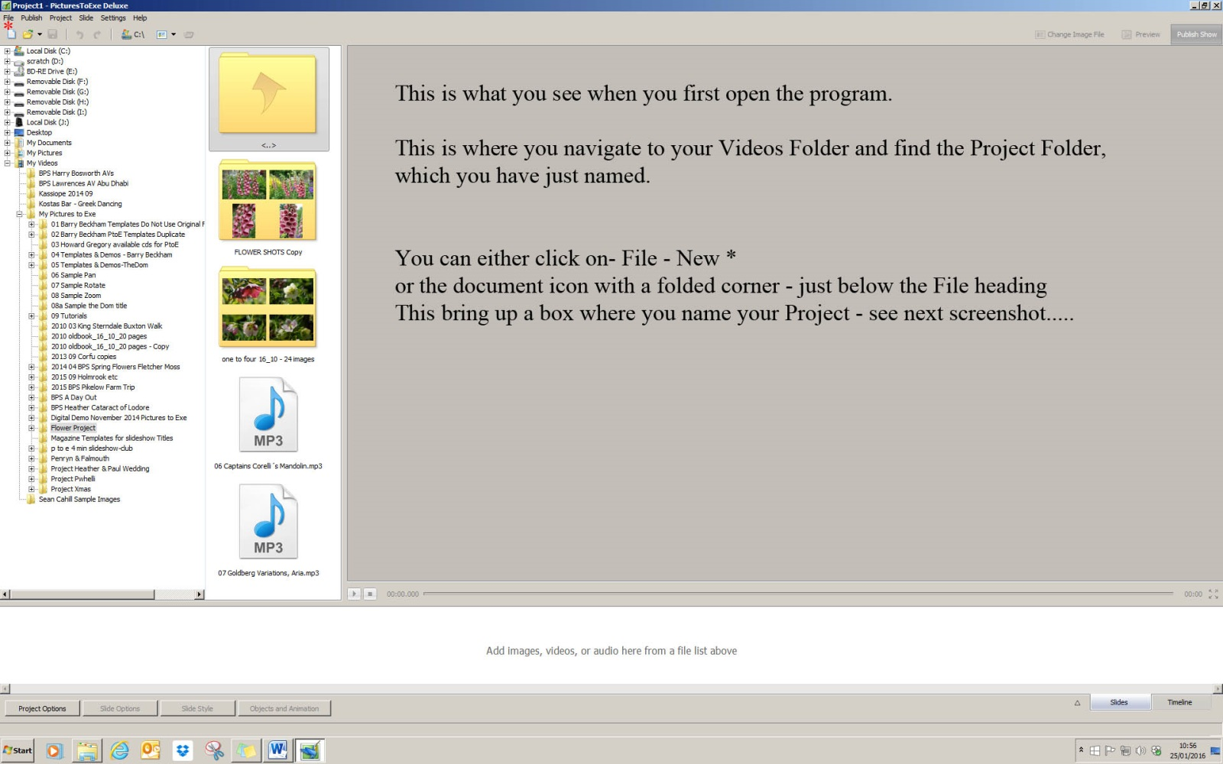

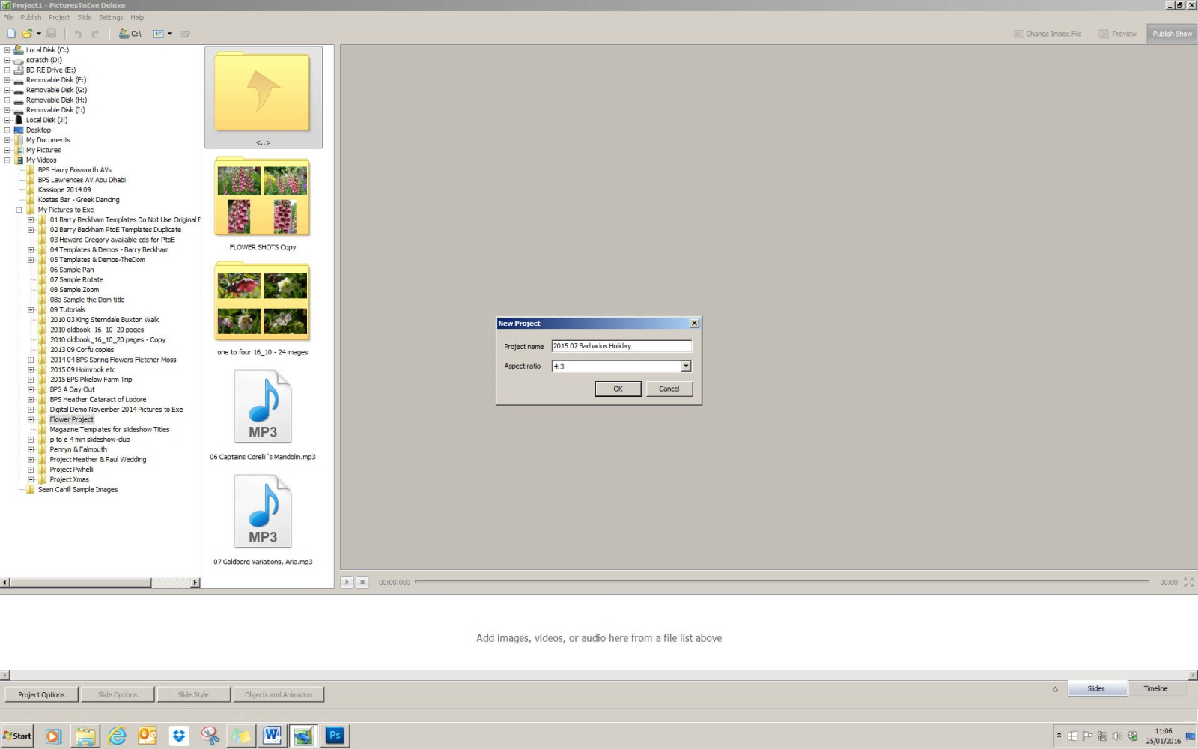

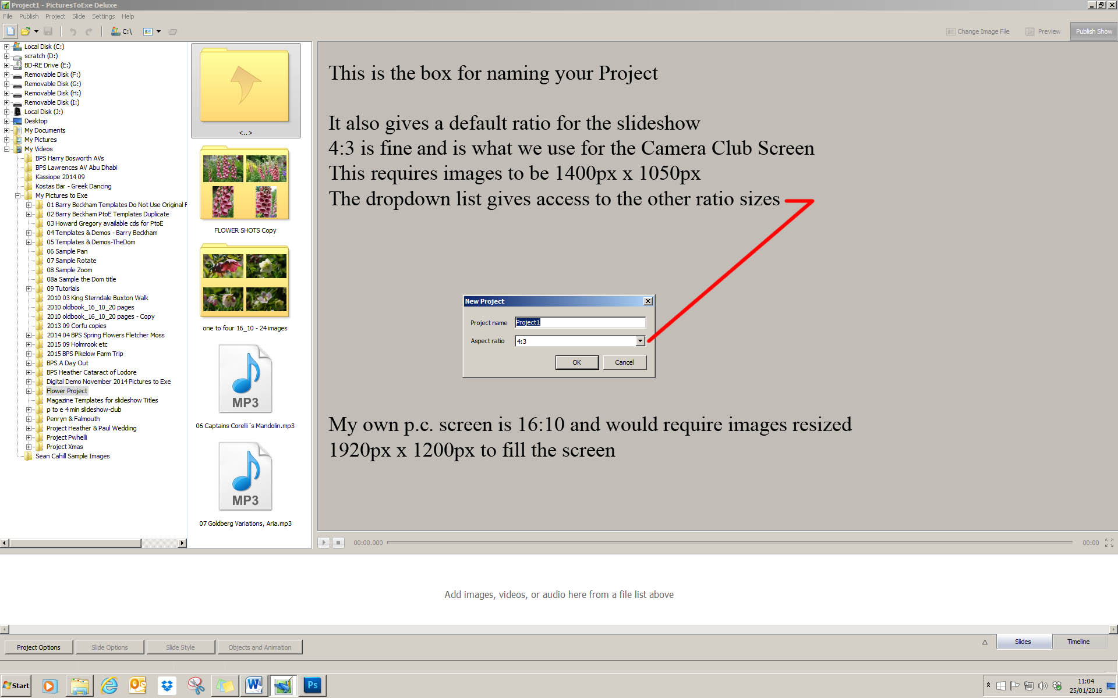

Now we can start adding images to the slideshow. Having located the folder with your resized images, simply right click on one image, and choose select all, then again right click and choose add selected images to slideshow. Or you can add them one at a time by dragging down to the white strip below which will hold all the slideshow images. The images can simply be dragged around to the order you require, so it is not necessary to have them all numbered sequentially. In the same way, if you decide you don’t want one of the images in you can drag it upwards above this line and it is removed, but still in your file of resized images. Or you can right click an image and choose remove image.
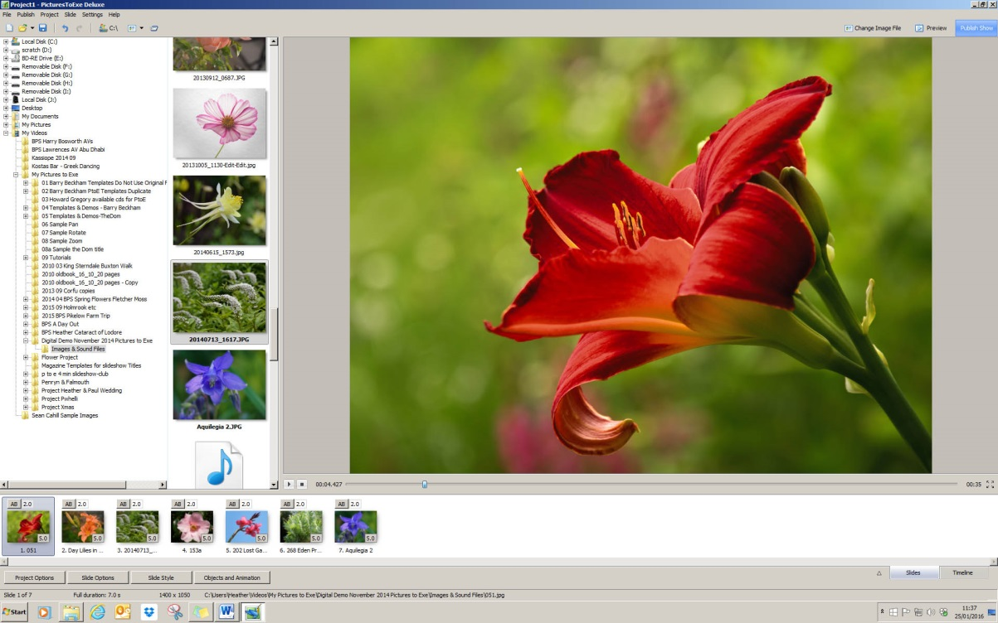
Your work space will now look something like this, with images across the ‘Slide Bar’
Alongside the Slide Tab is the Timeline Tab, and this is where you can view any music you have added, and adjust the length of time it plays/when it starts/a fade in/fade out.
The default timing for each slide is set at 5secs, but this can be altered via the Project Options Tab, at the base of the screen, then Main, this can affect one slide or all slides.
The next Tab in the Project Options is Audio – Click on Add Audio, and then navigate to your music folder within your Project Folder. Double click the track you want and it is placed into your Slideshow. By clicking on the Timeline at the lower right corner of the screen will show this track, and how long it is.
The track can be shortened, start later, fade etc. via the Project Options again under Audio, but I like to do this within the workspace, so you can see exactly what is happening.
To shorten the track in this way, to match the length of your slides, simply hover the mouse over the very end of the music track until you see a double ended arrow appear, then drag it to the left until you see the last slide. If you add another slide or make a few slides last a little longer, simply drag this line back again to match the new ending of the slides.
Sometimes a track might not start immediately, but has a silent part at the beginning – you may want to drag this end in too, so that the music starts immediately. Bear in mind, that a blank slide and a title will probably be being used. Doing this onscreen is most helpful.
Fading the music both in and out at the start and end can also be done in this way. This time, hover the mouse over the tiny black angle on the top corners of the music track and drag inwards for the amount of fade you require. This can be altered as many times as you require – simply keep listening and watching the beginning/end of your slideshow until you feel it is correct.
An even more precise way of adjusting fades is to hover the mouse over the thin orange line which runs halfway across the timeline – you will see a small dot appear as you move along the line. Hover till you see the dot, then click to place one at the beginning of the slideshow, and do the same again where you would like the music to arrive at full volume. This procedure can be replicated and used to even silence an area, anywhere along the timeline, where you might want to insert speech for instance. If you are not happy with your placement of these dots they can be left clicked and moved/altered to suit. If you simply want to get rid of them all after trying this, simply left click on one and drag it off the timeline! Do the same with the rest.
Remember – below the orange line reduces the volume – fading is a sloping line. Volume can be increased this way too, by going above the orange line. When you know you have all the images you want, plus a title for beginning and end and a blank start/end slide, you are ready to ‘fine tune’ the beg/end of your music track.
To alter the length of an individual slide, make sure you are in the Slide tab and not the TimeLine, and simply type in higher or lower seconds, not forgetting that any alterations will necessitate extending/shortening the music track on the Timeline.
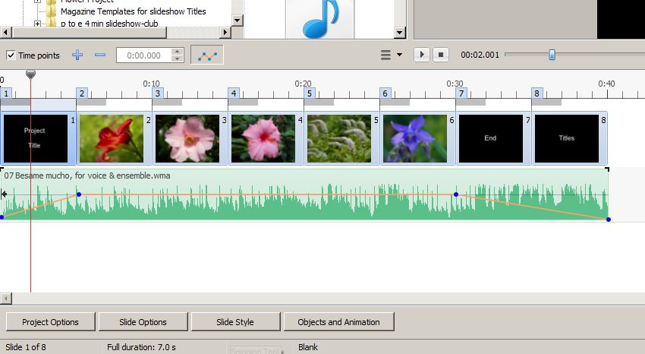

TO BE CONTINUED

Heather Carslake
28/01/2016

